Wetlands International European Association contributing to the hearings of the Commissioners-designate on topics of our interest.
From 30 September to 8 October, the European Parliament will hold public hearings to assess the commissioners’ skills and programmes. Once the hearings are completed, Parliament will vote into office the new Commission. Wetlands International European Association has sent some questions to the MEPs to give some input on issues we would like to get some policy developments on.
Please find below the question to commissioners in alphabetical order.
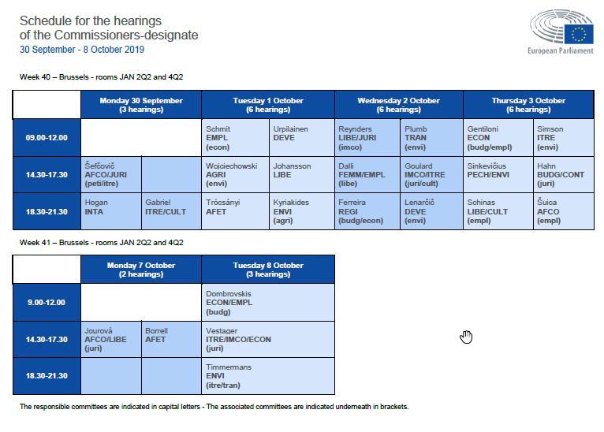DEVE Hearing of Janez Lenarčič, Commissioner-designate for Crisis Management
Upscaling Investment in Eco-drr solutions
Water-related disasters, like floods, droughts and storm surges, account for 90% of all disasters, and their frequency and intensity is increasing. In Europe for instance the key risk is flooding. Climate change is not the sole driver for the increasing frequency and intensity of disasters caused by natural hazards. Lack of integrated management of water and land resources is another key driver. These man-made disasters contribute to damages, losses of lives and displacement of people. There is a general need to increase societal and environmental resilience in the anticipation of increasing disaster risks, through the adoption of an integrated, inclusive, people-centered landscape approach and by contributing to effective risk management by connecting all stakeholders involved, starting with the communities at risk in the landscape.

Natural ecosystems such as wetlands, which act as natural buffer in the landscape, deserve much higher attention in DRR strategies and investments. Upscaling investments in ecosystem-based disaster risk reduction and climate change adaptation (eco-drr/cca) strategies should be a priority. Ecosystem-based solutions, such as for example “Building with Nature” and other engineered solutions which include ecosystem values and services, contribute to disaster and climate risk management, increase community resilience and reduce vulnerability of ecosystems and people and their displacement.
Questions to the Commissioner-designate
- Maintaining and restoring ecosystems, like wetlands, should be considered a major opportunity for investments of climate finance including by the private sector. Investments should be risk-informed to build climate and disaster resilience. What steps does the Commissioner designate envisage to increase investments in eco-drr solutions and to recognize the role of wetlands in DRR, as a significant and cost-effective component of DRR strategies?
ITRE hearing of Kadri Simson - Commissioner-designate Energy
Hydropower
The European Union's energy policy aims to achieve secure, affordable and climate–friendly energy. In achieving these goals, the EU has set ambitious targets as regards the use of renewable energy. Hydropower plays a role in the implementation of the Renewable Energy Directive but has major detrimental effects on both large and small rivers. Rivers are one of the most endangered ecosystems in the world and the ongoing construction of dams for electricity production in many of Europe’s rivers means that the ecological degradation persists. Few rivers are still free-flowing with serious implications for a number of migratory fish species such as eel and salmon.
Question to the Commissioner-designate:
- Given the interlinkages between water, energy and ecosystems, what steps does the Commissioner-designate envisage in order to ensure that fulfilling the EU renewable targets has no significant detrimental effect on habitats and species, in particular on freshwater ecosystems?
PECH/ENVI hearing of Virginijus Sinkevičius - Commissioner-designate Sinkevičius Environment and Oceans
The work of Wetlands International directly supports the work of DG Maritime Affairs on the protection of the European eel and we think these are relevant topics to bring to the attention of the new Commissioner.
European eel
The European eel stock is in critical condition. The decline in the eel stock has numerous causes including human activities such as fisheries (commercial, with 25% of the stock annually trafficked to Asia), hydropower turbines and pumps, pollution, habitat modification and the creation of obstacles to eel migration. A further deterioration of the status of the stock should be avoided. The EU Eel Regulation (Council Regulation (EC) No 1100/2007) establishes a framework for the protection and sustainable use of the stock of European eel. It has led to a major increase in public awareness; has led to the development of national management plans, and protective actions taken all over Europe and as a result recruitment indicators now suggest the stock is starting to recover, albeit from a very low base. However, implementation has come to a standstill while the stock is as yet insufficiently protected. Having initiated the eel protection policies, the EU is now in the key-position to provide feedback on national management plans, and in that way, reinforce and energise the national protection policies, all over the EU.

Questions to the Commissioner-designate:
- To achieve a healthy wild European eel population, Europe needs a more coordinated and integrated approach to its conservation and strengthened provisions of EU policies, aimed at reducing anthropogenic mortalities to a sustainable level. A reduction of fishing impacts alone will not achieve a sustainable management, and is unlikely to lead to recovery. Can the Commissioner-designate commit to prioritising the conservation of the eel? What does the Commissioner-designate plan to do to speed-up the implementation of protection, especially concerning the non-fishing impacts, which have hardly been reduced yet?
- The illegal export of European glass eels from Europe to Asia is a serious threat to species recovery efforts. Existing traceability systems across the EU are not sufficiently implemented to fully trace all eel trade even though Member States have been obliged to introduce adequate traceability systems since 2007 through Article 12 of the Eel Regulation. What does the Commissioner-designate propose in order to strengthen the implementation of article 12 to ensure the full traceability of eels at all life stages and to their final trade destination?
PECH/ENVI hearing of Virginijus Sinkevičius - Commissioner-designate Sinkevičius Environment and Oceans
Freshwater
Only 40% of EU coastal waters, lakes, rivers and wetlands are healthy, while 60% are currently unhealthy [EEA State of Water Report, 2018]. The EU Water Framework Directive is an important policy instrument to protect and restore our waters and has proven to be successful when properly implemented and enforced. Yet the actions taken to date by Member States fall far short of what is needed to bring Europe’s freshwater ecosystems into good health by the deadline of 2027 as required by the Water Framework Directive. Barriers to achieving the deadline include Member States’ lack of adequate funding for measures, the small scale of restoration measures and the persistent use of exemptions covering nearly half of Europe’s waters. In 2018-2019, the European Commission reviewed the Water Framework Directive as per the Better Regulation Guidelines: the Fitness Check of the EU Water Legislation.
Suggested questions to the Commissioner-designate:
- The EU’s waters suffer from ongoing pressures from physical changes to surface waters, agriculture and other land use, industry and hydropower. How will the Commissioner-designate ensure that the pace of ecological improvement of water bodies in Europe will overtake the pace of their degradation?
- The EEA 2018 State of Water Report showed that good ecological status for European waters is still a long way to go. Large-scale measures for ecological restoration are needed to tackle the enduring pressures on rivers and wetlands. Remaining free-flowing rivers in Europe urgently need strong protection. Can the Commissioner-designate outline what steps will be taken to ensure that Member States achieve the 2027 deadline by significantly stepping up their efforts and funding in the third river basin management cycle?
- Turning back the clock on water body deterioration cannot be done without strong legislation. During the Fitness Check of the EU Water Legislation, 375,000+ European citizens have called on the European Commission to defend Europe’s strong water law, making the public consultation on the legislation one of the largest ever in the history of the European Union. Can the Commissioner-designate conclude that the Water Framework Directive is “fit for purpose” and that there is an urgent need for strengthening the Water Framework Directive’s implementation?
DEVE hearing of Jutta Urpilainen, Commissioner-designate for International Partnership
SAHELIAN WETLANDS
Wetlands are the most rapidly declining ecosystems in the world. As they are lost or lose their ability to effectively store and regulate water and to support food production, people are deprived of their well-being too, leading to social tensions, conflicts and eventually human displacement. Water crisis should be seen as both societal and environmental risks.
The Commission's Directorate-General for International Cooperation and Development (DG DEVCO), in a recent reference document “Deeper than water”, has recognised that wetlands are in decline, undervalued and are victims of climate change, land use change, human activities. In the EU Consensus of development it comes clear that healthy and resilient ecosystems are vital for human wellbeing.
Furthermore Mrs Mogherini recently said that "Climate change multiplies threats to peace and security as it adds pressure to already fragile livelihoods and destabilises local communities and their environments. Food insecurity, water scarcity and environmental degradation often lead to competition over natural resources, and tensions as communities are forced to flee and migrate in search for a better future.
Question to the Commissioner International Partnerships:
- Could the Commissioner designate commit to discuss, within the framework of a comprehensive strategy for Africa, a joint EU Africa plan for the sustainable management of natural resources to enhance resilience to climate change and in that discussion including to recognise Sahelian wetlands as critical natural assets to be safeguarded and restored?
AGRI hearing of Janusz Wojciechowski, Commissioner-designate for Agriculture
Peatlands in the new CAP
Over centuries, European peatlands have been drained for agriculture, forestry and peat extraction. Peatlands represent the world’s most effective carbon stores. Globally they cover 3% of the land surface but they hold 25% of terrestrial carbon – two times more than all the world’s forests biomass combined. When peatlands are drained for cultivation, they become net carbon emitters instead of active carbon stores.
Paludiculture presents the necessary paradigm shift towards sustainable regional economies with global climate benefits. Instead of draining them, peatlands are kept productive under permanently wet, peat-conserving conditions. It provides valuable ecosystem services that are not (yet) paid, including reduction of GHG emissions, protection of ground- and surface water, retention of water in the landscape and conservation of biodiversity. From a macroeconomic point of view, transfer payments to farms that put paludiculture into practise are therefore a very cost-effective way to fulfil international commitments with respect to protecting climate, water and biodiversity.
Despite the cost-effectiveness of paludiculture, the current CAP discriminates crops suitable for cultivation on wet or rewetted peatlands (e.g. reed, cattails, sedges and peat mosses) as not eligible for payments within the pillar I in most Member States. There are no incentives for farmers to raise water levels and shift to more climate-friendly farming on organic soils. On the contrary, drainage-based agriculture with adverse environmental impact for climate, water, soil and biodiversity is supported by CAP subsidies.
Questions to the Commissioner-designate:
- How is the Commissioner planning to ensure the achievement of environmental and climate related objectives of the CAP, including wetlands/ peatlands protection? Would you commit to establish EU wide environmental and climate policy targets integrated into CAP to ensure ambitious efforts in the Member States? How would you include low-emission farming practices (e.g. paludiculture on peatlands) into the future CAP?

