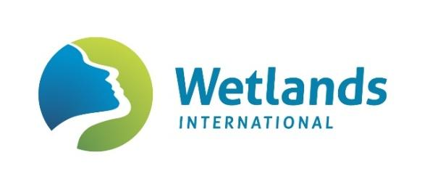
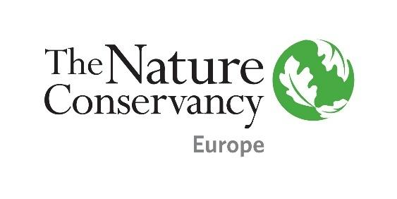

EVENT
Rivers as Lifelines: Restoration & Protection of Freshwater in Europe
At the occasion of EU Green Week and World Fish Migration Day 2020

Date: October 2020, Thursday 15th 10.30-15.45 CET
Venue: Online

Organising Partners: The Nature Conservancy Europe (TNC) and Wetlands International Europe

Moderator: Chris Baker, Programme Head Water Resources at Wetlands International

10.30 | Welcome
 | The Current Situation for Freshwater in Europe
10.30-11.00 | Rivers in Europe Today: The Situation | Yurena Lorenzo - Wetlands International  Pär Holmgren - European Parliament Representative  Hans Stielstra - European Commission (DG ENV)
 | Free-flowing Life-Lines for All - River Conservation
11.00-11.15 | The Main Pressures on Freshwater Ecosystems & Water Quality | Eef Silver - Wetlands International
11.15-11.30 | Why Protect and Restore Rivers & Why  Now? Natural, Economic, Social Benefits & Policy Context | Henrik Österblad - TNC
11.30-11.45 | Coffee break
 | A Legal Framework in Place – Water Framework Directive & National Law: Achieving Good Ecological Status by 2027 - through Protect and Restore
11.45–12.15 | Legal Basis and Rationale for supporting River Restoration and Protection | Hans Stielstra - European Commission (DG ENV)  Eef Silver - Wetlands International
12.15–12.45 | Panel Discussion – River Conservation in Member States: Effective Restoration & Protection to date, Successful legal frameworks for River Conservation at National Level | Saija Koljonen (FI)  Daniel Rojšek (SI)  Corinne Belveze (FR)  Fernando Magdaleno (ES)  - Member State Representatives
12.45-13.45 | Lunch break
 | The Tools for River Conservation – Funding, Designations & Definitions
13.45–14.00 | The Money Flow: Financing Restoration | Wouter Helmer & Helena Newell - Rewilding Europe
14.00-14.15 | Durable River Protection Designations & the Wild and Scenic Rivers Act | Tara Moberg - TNC
 | Zooming in: Lessons learned in the Western Balkans current evolving restoration and protection
14.15-14.30 | The Western Balkans – Pristine Rivers, Abundance and Threats | Irma Popović Dujmović - WWF Adria
14.30-14.45 | Tea break
 | The Outlook & Challenges ahead
14.45-15.00 | Panel discussion: The Green Deal & Green Agenda for the Western Balkans and views from the region | Madalina Ivanica - European Commission (DG ENV)  Neven Trenc - Croatian Ministry for Sustainable Development, Institute for Nature Protection  Irma Popović Dujmović - WWF Adria
 | Scaling up: Europe
15.00-15.15 | EP Resolution on the Water Framework Directive | Claire Baffert - Living Rivers Europe NGO coalition
15.15-15.45 | Practical and Legislative Outlook to Conserve and Restore Rivers – summary from the discussions  Closing Statements | Marianne Kleiberg – TNC  Chris Baker – Wetlands International

